2025 Maryland Clean Energy Summit Partner Toolkit
Event Link: https://bit.ly/3I5S4MM
High-Level Messaging
The 2025 Maryland Clean Energy Summit is the state’s premier clean energy conference that gathers industry leaders—including state officials, policymakers, utility representatives, transmission & distribution experts, innovators, advocates and nonprofits—to examine and find solutions to the most pressing energy challenges facing Maryland. This year’s conference, themed “Balancing Supply, Demand & Sustainability: Innovation in the Energy Marketplace,” will explore emerging climate solutions and strategies and how they can contribute to economic growth in Maryland.
Sample Event Listing
Event Name: 2025 Maryland Clean Energy Center
Date: October 14-15, 2025
Location College Park Marriott Hotel & Conference Center
Hosted by the Maryland Clean Energy Center (MCEC), this annual event serves as the premier clean energy conference in Maryland. The 2025 Maryland Clean Energy Summit, themed “Balancing Supply, Demand & Sustainability: Innovation in the Energy Marketplace,” will bring together leaders in policy, finance transmission, distribution, and more to explore emerging climate solutions and strategies and how they can contribute to economic growth in Maryland. This two-day conference will feature industry-specific roundtable and breakout sessions, two full-conference plenaries, lawmaker/Public Service Commission meet & greets, numerous networking opportunities, featured activities, and lunch on both days. Visit the MCEC website for more information!
Sample Email/Newsletter Language
Headline: Join us at the Maryland Clean Energy Summit!
Join [COMPANY NAME] on October 14-15 at the 2025 Maryland Clean Energy Summit for two full days of industry-specific roundtable and breakout sessions, plenaries, networking opportunities, and more! Hosted by the Maryland Clean Energy Center (MCEC), this year’s conference is themed “Balancing Supply, Demand & Sustainability: Innovation in the Energy Marketplace” and will bring together leaders in policy, finance transmission, distribution, and more to explore emerging climate solutions and strategies and how they can contribute to economic growth in Maryland. Visit the MCEC website for more information!

Sample Social Media Posts
Event Hashtag: #MCECSummit
MCEC Hashtag (General): #PoweredByMCEC
Post 1:
[COMPANY NAME] is proud to support the 2025 Maryland Clean Energy Summit. Join us on October 14-15 as @MDCleanEnergy gathers the foremost clean energy leaders to explore how addressing climate challenges can help boost economic growth.
Learn more: https://bit.ly/3I5S4MM
Post 2:
Starting or trying to finish your clean energy project? Join [COMPANY NAME] at the 2025 Maryland Clean Energy Center to learn about solutions to catalyze your work, including finance programs & procurement services offered by @MDCleanEnergy.
Buy Tickets: https://bit.ly/3I5S4MM
Post 3: MCE
Join [COMPANY NAME] at the 2025 Maryland Clean Energy Summit on October 14-15! This annual conference brings together leaders in policy, transmission, distribution, finance & more to address pressing climate challenges facing Maryland.
Learn More: https://bit.ly/3I5S4MM
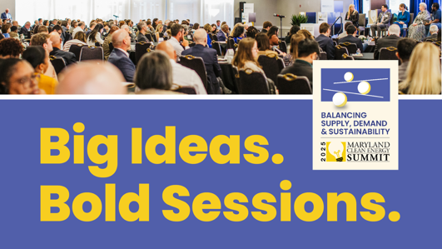
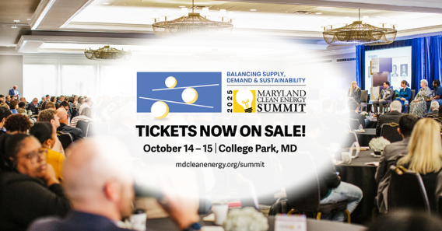
Graphics

Click Here to Download via Dropbox

